Masterclass TU/e

Notes and Exercises

21 April 2023
Maks Burchard, 5V3, Wiskunde D

Content
Summary 4
Vrijdag 31 Maart 5
Nodes & Edges 5
Degree 5
Clique 5
Exercise 1 6
Exercise 2 6
Paths, Distance, and S 6
Shortest Path 6
Distance 6
Eccentricity 6
Diameter 7
Radius 7
Exercise 7 7
Exercise 3 7
Communities 8
Exercise 4 9
Exercise 5 9
Exercise 6 9
The k-centre Algorithm 10
Bottlenecks 10
Exercise 8 11
Exercise 9 11
Modularity 12
Exercise 10 12
Simple Modularity 12
Exercise 11 12
Models of Communities 13
Planted Partition Model (PPM) 13
Exercise 12 13
Exercise 13 13
Exercise 14 13
Exercise 15 14
Exercise 16 14
Exercise 17 14
Exercise 18 14
Woensdag 5 April 14
Networks 14
Dijkstra’s Algorithm 14
How to improve Dijkstra’s algorithm (in terms of speed) 16
Bidirectional Dijkstra 16
A-star Algorithm 17
Applying Dijkstra In A Non-Standard Setting 17
Normal Distribution 18
Exercise 19 20
Exercise 21 20
Travel Time As Random Variable 22
Arriving In Time 22
Exercise 22 23
Concluding Remarks 24

Summary
As an assignment for my mathematics D, I went to a masterclass to the TU/e. The masterclass was spread over 2 days, the first was on Friday the 31st of March and the second was on Wednesday the 5th of April. The classes were given by Nicos Starreveld and Mehmet Akif Yildiz. I did not have many expectations going into the class, but the class did surprise me. It showed me math from a new angle, more akin to data science which is one of the studies that I am considering doing. This math class was very interesting and if more classes like these would be available, I would consider taking them.

Vrijdag 31 Maart

Nodes & Edges
A node (or vertex) is a point in a graph. The set of nodes is V.
An edge is a connection between two nodes. The set of edges is E.
For example, Graph (V, E) whereby V = {1, 2, 3, 4, 5, 6} and E = {{1, 2}, {1, 5}, {2, 3}, {2, 5}, {3, 4}, {4, 5}, {4, 6}} can be drawn in two ways:

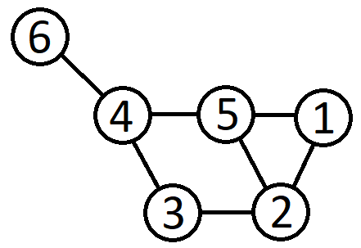and 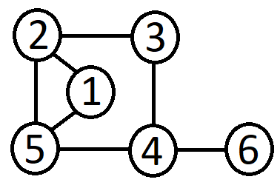
Graph 1 and graph 2

With |V| nodes you can construct in total $2^{\left({\left|V\right| \atop 2}\right)}$graphs, where $\left({|V| \atop 2}\right)= \frac{\left|V\right| * (\left|V\right|-1)}{2}$.
For example
for |V| = 3 , we can construct $2^{3}=8$ graphs.
for |V| = 4 , we can construct $2^{6}=64$ graphs.

Degree
d(x) is the degree of a node x in a graph G = {V, E}.
It means the number of neighbours of x, that is the number of edges incident to x.
For any graph G = (V, E), it is true that $\sum_{i∈v}{d\left(i\right)=2|E|}$.
Proof: Each edge {a, b} of the graph G = (V, E) contributes the degree of a and b by one. In other words, each edge {a, b} is counted on the left-hand summation twice: One in d(a) and one in d(b).

Clique
A clique is a group of nodes where all nodes have edges to each other.
In the graph below, {1, 2, 3, 4} is a clique because {1,2} {1,3} {1,4} {2,3} {2,4} {3,4} are edges.
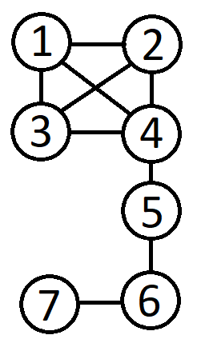
Graph 3

Exercise 1
Show that in a graph G = (V, E) the maximum number of edges is equal to $\frac{\left|V\right| * (\left|V\right|-1)}{2}$.
Each possible edge in a graph G = (V, E) corresponds to a pair of nodes. In total we have |V| nodes in G, which means we can form in total $\left({|V| \atop 2}\right)$ possible pairs of nodes, where {i, j} is considered the same as {j, i}.

Exercise 2
Show that you can construct in total $2^{\left({\left|V\right| \atop 2}\right)}$ graphs with |V| nodes.
In graph G there are in total $\left({|V| \atop 2}\right)$ possible edges (see exercise 1). In a specific graph some of these edges will be present and some not. Hence the total number of graphs with |V| nodes is equivalent to the number of sequences of length $\left({|V| \atop 2}\right)$ where each element is either a 0 (edge is not present) or a 1 (edge is present). There are in total $2^{\left({\left|V\right| \atop 2}\right)}$ such sequences.

Paths, Distance, and S
A path between nodes a and b is a sequence of edges which joins a sequence of nodes from a to b.

Shortest Path
A shortest path between the nodes a and b is a path from a to b using the least amount of edges.

Distance
Distance (Dist (i, j)) is the number of edges on the shortest path, i.e. the length of the shortest path.
In the graph below, the distance between nodes 1 and 2 is 1, the distance between nodes 1 and 4 is 2 and the distance between nodes 2 and 6 is 3.

Graph 1

Eccentricity
Let S be part of graph (sub-graph, possibly the whole graph).
For any vertex i in the graph, the eccentricity of i is defined as Ecc (i, S) = ${max \atop j∈s}$ Dist (i, j).
In plain words this means that eccentricity is defined as the longer of all shortest paths that exists for the node to any another node that is in S. The node is the more eccentric the more it lays on the edge of the graph.
For graph 1: Ecc (1, {2,3,4}) = max {Dist (1,2), Dist (1,3), Dist (1,4)}
Dist (1,2) = 1, Dist (1,3) = 2, Dist (1,4) = 2
Ecc (1, {2,3,4}) = max {1,2,2} = 2

Diameter
The diameter of S is defined as Diameter (S) = ${max \atop j∈s}$ Ecc (i, S)
In plain words this means that the diameter of a sub-graph is defined as the longest of all shortest paths withing the sub-graph.
In graph 1: Diameter ({1, 3, 6}) = 3 and Diameter (G) = 3

Radius
The radius of S is defined as Radius (S) = ${min \atop j∈s}$ Ecc (i, S)
In plain words this means that the radius of a sub-graph is defined as the shortest of all shortest paths within the sub-graph.
In graph 1: Radius ({3, 5, 6}) = 2 and Radius (G) = 2

Exercise 7
The diameter of a circle is always twice the radius. Does this also hold for graphs? Experiment with some simple graphs. You may assume that the graph is connected.
No, proof:
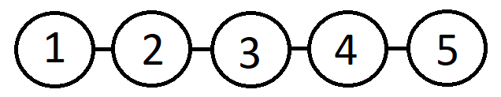
Graph 4
In graph 4: Diameter (G) = 5 and Radius (G) = 3 and 3/5 ≠ ½
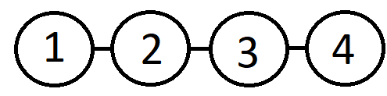
Graph 5
In graph 5: Diameter (G) = 3 and Radius (G) = 2 and 2/3 ≠ ½
Q.E.D.

Exercise 3
Look at the karate network in figure 2.0.1 (below). Answer the following questions:
- What are the degrees of points 0, 1, 8, and 33?
- What are the eccentricities of points 0, 1, 8, 15, 16 and 33? For these computations consider S either as the pink or the green community given in the figure.
- What are the diameter and radius of the two subnetworks? Can you give an intuitive explanation of the values you got?
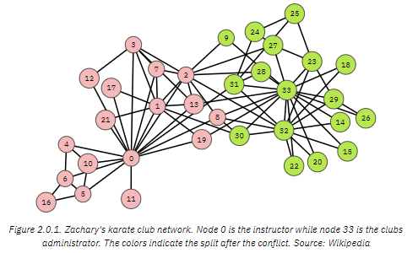
A. d(0) = 16, d(1) = 8, d(8) = 5, d(33) = 17.
B. Ecc(0, Pink) = 3, Ecc(1, Pink) = 4, Ecc(8, Pink) = 4, Ecc(15, Green) = 3, Ecc(16, Pink) = 4, Ecc(33, Green) = 2.
C. Diameter (Pink) = 4, Radius (Pink) = 2, Diameter (Green) = 3, Radius (Green) = 2.

Communities
Communities are groups of network-nodes that are better connected internally than externally. There is no clear definition of what a community is. There are many different ideas of what communities should look like. Communities resemble cliques, but they don’t have to necessarily be one. There are few links between communities and there is a lower cut size inside communities than outside communities (Cut (C) = L (C, N\C)). The problem with defining communities by minimizing cut size is that this often leads to unbalanced communities. The solution to this is to normalize by the size of the ratiocut. Ratiocut (C) = Cut (C)/(|C|*|N\C|).

Exercise 4
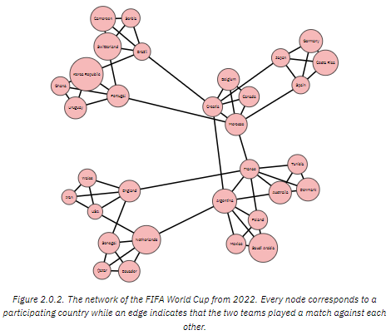
Look at the FIFA World Cup from 2022 in Figure 2.0.2. Answer the following questions.
A How would you divide the network in communities in order to obtain the lowest cut-size?
B How would you divide the network in communities in order to obtain the lowest RatioCut value between communities?
A By cutting ENGLAND-FRANCE and NETHERLANDS-ARGENTINA you get 2 communities, and the cut-size is 2.
B By cutting BRAZIL-CROATIA, PORTUGAL-MOROCCO, NETHERLANDS-ARGENTINA, ARGENTINA-CROATIA, ENGLAND-FRANCE, MOROCCO-FRANCE, FRANCE-ARGENTINA, and POLAND-FRANCE, you get a division with the lowest RatioCut.

Exercise 5
What is the size of the largest clique of the FIFA2022 network of figure 2.0.2?
The size of the largest clique of the FIFA2022 network of figure 2.0.2 is 4. There are 6 cliques with the size of 4. Each one corresponds to each of the groups in the tournament.

Exercise 6
In the karate network, the conflict that led to the split (called ‘true split’) was a conflict between nodes 0 and 33 (the instructor and the administrator). Thus, we want to find a split into two communities such that the instructor and the administrator are in different communities. What is the cutsize, see (2.1.1), of the ‘true split’? Can you find a split that has a lower cutsize than the ‘true split’?
The cutsize of the true split is 11. By moving node 8 from the pink to the green community you get a cutsize of 10 instead of 11.

The k-centre Algorithm
The k-centre algorithm divides the graph into k communities.
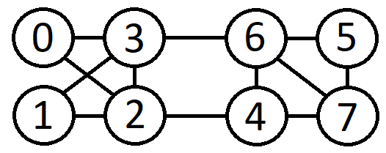
Graph 6
- Assign k vertices as centres c1, …, ck
- Assign each node to the nearest centre: C(i) = arg ${min \atop j=1,…,k}$ Distance (i, c_{j})
- Update centres to the centres of these communities
- Repeat from step 2. (Until nothing changes.)

Bottlenecks
Bottlenecks are edges where a lot of shortest paths go over. Links between communities often create bottlenecks. Bottleneckness (i, j) = |{(s,t): the links ij on a shortest path from s to t}|
In graph 6: Bottleneckness (2, 4) = |{(2, 4) (1, 4) (2, 7) (2, 6) (2, 5) (1, 7) (0, 4) (0, 7) (3, 4)}| and Bottleneckness (5, 7) = |{(5, 7) (5, 4) (5, 2)}|
The edge (2, 4) has a higher bottleneckness than the edge (5,7).



Exercise 8
Apply the k-centre algorithm to the Karate network from Figure 2.0.1. In the first iteration, you can assign nodes 0 and 33 (the instructor and administrator) as the centres. In case you encounter ties (that is, a node that is at equal distance of both centres, or multiple nodes with equal eccentricity), you can resolve them by choosing the node with the lowest index.
Node | Distance to 0 | Distance to 33 | 0: A or 33: B
0 | 0 | 2 | A
1 | 1 | 2 | A
2 | 1 | 2 | A
3 | 1 | 3 | A
4 | 1 | 3 | A
5 | 1 | 3 | A
6 | 1 | 3 | A
7 | 1 | 2 | A
8 | 1 | 1 | A
9 | 2 | 1 | B
10 | 1 | 3 | A
11 | 1 | 3 | A
12 | 1 | 3 | A
13 | 1 | 1 | A
14 | 3 | 1 | B
15 | 3 | 1 | B
16 | 2 | 4 | A
17 | 1 | 3 | A
18 | 3 | 1 | B
19 | 1 | 1 | A
20 | 3 | 1 | B
21 | 1 | 3 | A
22 | 3 | 1 | B
23 | 3 | 1 | B
24 | 2 | 2 | A
25 | 2 | 2 | A
26 | 3 | 1 | B
27 | 2 | 1 | B
28 | 2 | 1 | B
29 | 3 | 1 | B
30 | 2 | 1 | B
31 | 1 | 1 | A
32 | 2 | 1 | B
33 | 2 | 0 | B

Exercise 9
Consider a ‘line’ network of an even number of nodes. That is, nodes are labelled 1, 2, … , n (where n is even) and nodes are connected if their labels differ by exactly one. Which edge has the highest bottleneck-ness of this network?
Edge (n/2, (n/2)+1) has the highest bottleneck-ness of this network.

Modularity
Communities contain more links than if the graph was completely random. By ‘completely random’ is meant that you randomly place E edges among N(N-1)/2 node-pairs.
Simple modularity $\left(c\right)=\frac{1}{|E|}*(\sum_{i=1}^{|c|}{L\left(C1\right)- \left({|Ci| \atop 2}\right)* Density(N))}$
$\sum_{i=1}^{|c|}{L\left(C1\right)}$ calculates the amount of edges.
$\left({|Ci| \atop 2}\right)* Density(N)$ calculates the expected amount of edges.
Density = |E|/ $\left({|N| \atop 2}\right)$
Alternatively: the fraction of edges inside communities minus the fraction of node-pairs inside communities minus the fraction of node-pairs inside communities.
Modularity does not specify the number of communities.

Exercise 10
For exercises 10 until 18 we consider a network with k equally-sized communities C1, …, Ck (each of size s>2). Each of the communities forms a clique while each two neighbouring communities (i.e., community C, and C_{r+1} for r = 1, …, k – 1 or Ck and C1) are connected by a single edge. We refer to this network as the ring-of-cliques network. Figure 4.0.1 shows the corresponding network for k = 4 and s = 5.
What is the Simple Modularity of this ring of cliques?
1/44 * (40-4($\left({5 \atop 2}\right)$ * 44/$\left({20 \atop 2}\right)$) = 0,6985645933.

Simple Modularity
Simple modularity $\left(c\right)=\frac{1}{|E|}*(\sum_{i=1}^{|c|}{L\left(C1\right)- \left({\left|Ci\right| \atop 2}\right)*\frac{\left|E\right|}{\left({|M| \atop 2}\right)})}$.
When you write the formula for simple modularity out in words, you get:
Simple modularity (c) = 1/Amount of Edges * (Amount of edges inside all communities – the amount of communities * ($\left({Amount of nodes in a community \atop 2}\right)$ * amount of edges/$\left({Amount of nodes \atop 2}\right)$)).
Another way to write out the formula for simple modularity is:
1/Amount of Edges * (B for community one + B for community two + … + B for community n), where:
B = (Amount of edges in a community – $\left({Amount of nodes in a community \atop 2}\right)$ * amount of edges/$\left({Amount of nodes \atop 2}\right)$.

Exercise 11
Now consider the partition that is obtained by when combining clique C1 and C2 into one community of size 2s. Show that for k sufficiently large, the simple modularity of this new partition is actually higher than that of the original, more sensible partition.
There are $\left({s \atop 2}\right)$ edges inside a community. In total there are k * $\left({s \atop 2}\right)$ edges inside the cliques and k edges between the cliques. This means:
$$Simple Modularity \left(C\right)= \frac{1}{k*\left(1+\left({s \atop 2}\right)\right)}*k*(\left({s \atop 2}\right)-\left({s \atop 2}\right)*\frac{k*\left(1+\left({s \atop 2}\right)\right)}{\left({k*s \atop 2}\right)}= \frac{\left({s \atop 2}\right)}{1+\left({s \atop 2}\right)}\left(1-\frac{k*\left(1+\left({s \atop 2}\right)\right)}{\left({k*s \atop 2}\right)}\right)=\frac{\left({s \atop 2}\right)}{1+\left({s \atop 2}\right)}-\frac{k*\left({s \atop 2}\right)}{\left({k*s \atop 2}\right)}=\frac{\left({s \atop 2}\right)}{1+\left({s \atop 2}\right)}-\frac{s-1}{k*s-1}$$
The number of edges inside the communities increases by 1 (The edge between C1 and C2) while the number of intra-community pairs increases by |C1|*|C2| = S^{2.}
Hence, the expected number of edges inside the communities increases with:
$$s^{2}*\frac{k*\left(1+\left({s \atop 2}\right)\right)}{\left({k*s \atop 2}\right)}=s\frac{s+1}{k*s-1}$$
Thus, simple modularity increases whenever $1>s\frac{s+1}{k*s-1}$ and this can be rewritten to:
$$k>s+1+\frac{1}{s}$$
Therefore, for a sufficiently large number of cliques, merging two adjacent cliques results in an increase in the simple modularity. This shows that maximizing simple modularity does not always result in natural communities.

Models of Communities

Planted Partition Model (PPM)
A planted partition model has density P_{in} inside communities and P_{out} between communities.
$P (ijεE)\left\{\begin{aligned}Pin if C(i) = C(j) \\ Pout if C(i) ≠ C(j)\end{aligned}\right.$

Exercise 12
For a PPM consisting of k communities each of size s, what is the expected degree of a node? And what is the expected density of the network as a whole?
Expected degree: (s - 1)*P_{in} + (k - 1)*s*P_{out}
Expected density: $\frac{\left(S-1\right)*Pin+\left(k-1\right)*s*Pout}{\left|N\right|-1}$

Exercise 13
For a PPM consisting of k communities each of size s, what is the expected value of the Simple Modularity of the ‘true’ community structure?
$$k\left({s \atop 2}\right)*(Pin-Density(N))$$

Exercise 14
For a PPM consisting of k communities each of size s, what is the probability that a given node i is not connected to any of its community members? What is the expected number of nodes in the network that are not connected to any of their community members?
Probability that node i is not connected to its community members: (1 - P_{in})^{s-1}
Expected number of nodes not connected to their community members: n*(1 - P_{in})^{s-1}

Exercise 15
What is the expected radius of a community consisting of s nodes?
Each node has the probability (1 - P_{in})^{s-1}, a positive number, of not being connected to any community members. This leads to an infinite distance, giving us a radius of: $∞*{\left(1-Pin\right)}^{s-1}= ∞$

Exercise 16
What is the expected cutsize between two communities? And what about the ratio cut?
The expected cutrate is S² x P_{out} and the expected ratiocut is P_{out}.

Exercise 17
We say that a node s is a common neighbour of i and j it is a neighbour of both i and j. That is, whenever {i, s} ε L and {s, j} ε L. What is the expected number of common neighbours that two nodes have if they are in the same community? And what is the expected number of common neighbours for two nodes that are not in the same community?
The expected number of common neighbours between two community members is: (s - 1)*(P_{in})² + (k - 1)*s*(P_{out})²
The expected number of common neighbours between two nodes in different communities is: 2*(s - 1)*P_{out}*P_{in} + (k - 1)*s*(P_{out})²

Exercise 18
Consider a PPM (not sparse) with P_{in} = ½ with two communities with sizes s1 and s2 where 2 < s1 < s2. Which of the two communities has a higher expected number of nodes that are not connected to the rest of the community?
s1. Every node has the same chance to connect to a random node i. Minimizing the amount of nodes increases the chance of having unconnected nodes, therefore the smaller community will have a higher likelihood of containing unconnected nodes.

Woensdag 5 April

Networks
Why should you study networks?
What is the shortest route to reach your destination?

Dijkstra’s Algorithm
Put the shortest path in the table.
If new shortest path found, it becomes the value in the table.
1 Mark distances from start to neighbouring nodes.
2 Find shortest path to any node in explored network.
3 Mark node to which the shortest distance as permanent.
4 Repeat 1-4 with the new permanent node.
(If there is a tie, then it doesn’t matter which of the tied nodes you choose.)
End when FINISH becomes a permanent node.
Example:
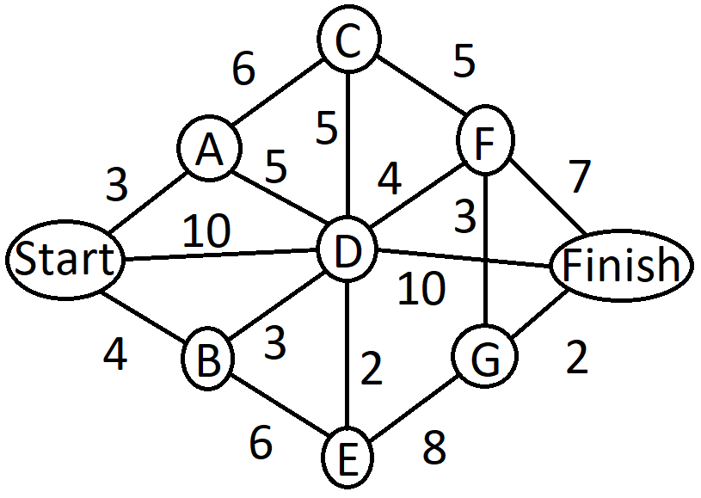
Graph 7
Using Dijkstra’s algorithm, gives us this:
A | B | C | D | E | F | G | Finish
3, Start | 4, Start |  | 10, Start
* | 4, Start | 9, A | 8, A
* | * | 9, A | 7, B | 10, B
* | * | 9, A | * | 9, D | 11, D |  | 17, D
* | * | * | * | 9, D | 11, D |  | 17, D
* | * | * | * | * | 11, D | 17, E | 17, D
* | * | * | * | * | * | 14, F | 17, D
* | * | * | * | * | * | * | 16, G
The shortest path from start to finish in graph 7 is to go StartBDFGFinish.
Another example is:
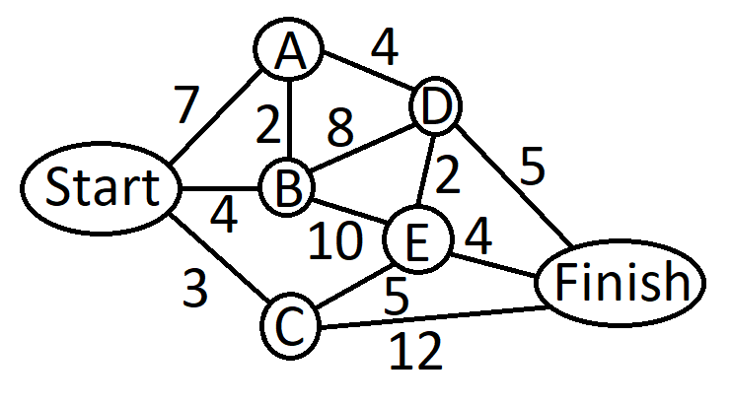
Graph 8
A | B | C | D | E | Finish
7, Start | 4, Start | 3, Start
7, Start | 4, Start | * |  | 8, C | 15, C
6, B | * | * | 12, B | 8, C | 15, C
* | * | * | 9, A | 8, C | 15, C
* | * | * | 9, A | * | 12, E
* | * | * | * | * | 12, E
The shortest path from start to finish in graph 8 is to go StartCEFinish.

How to improve Dijkstra’s algorithm (in terms of speed)
Take the location of the destination into account, which can be used in Bidirectional Dijkstra or the A-star algorithm.

Bidirectional Dijkstra
From graph 8, using bidirectional Dijkstra, we get the following:
Forward: Backwards:
A | B | C | D | E | Finish
7, S | 4, S | 3, S
7, S | 4, S | * |  | 8, C | 15, C
6, B | * | * | 12, B | 8, C | 15, C
A | B | C | D | E | Finish
 |  | 12, F | 5, F | 4, F
 | 14, E | 9, E | 5, F
8, D | 13, D | 9, E

Claim: We have found the optimal path when the sum of the distance of the new permanent nodes is longer than the distance of the shortest path
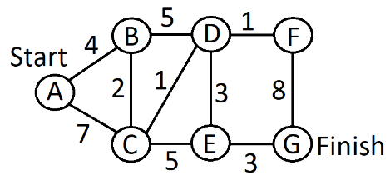
Graph 9
For graph 9:
Forward: Backwards:
B | C | D | E | F | G
4, A | 7, A
* | 6, B | 9, B
* | * | 7, C | 11, C
* | * | * | 10, D | 8, D
A | B | C | D | E | F
 |  |  |  | 3, G | 8, G
 |  | 8, E | 6, E | * | 8, G
 | 11, D | 7, D | * | * | 7, D
 | 11, D | 7, D | * | * | *

In the second line of the algorithm, the shortest path is 14 in length (ABCEG) and the sum of distance of the new permanent nodes is 12 (6+6). 12 < 14 so we have not yet found the optimal path.
In the third line of the algorithm, the shortest path is 13 in length (ABCDEG) and the sum of distance of the new permanent nodes is 14 (7+7). 14 > 13 so we have found the optimal path.

A-star Algorithm
Idea: Only update the nodes located between origin and destination.
How? By estimating future costs.
In graph 9, but with D instead of A as a starting point:
A | B | C | D | E | F | G
9 | 8 | 7 | 6 | 4 | 2 | 0
 | 13, 5, D | 8, 1, D | * | 7, 3, D | 3, 1, D
 | 13, 5, D | 8, 1, D | * | 7, 3, D | * | 9, 9, F
 | 13, 5, D | 8, 1, D | * | * | * | 6, 6, E
Row 2 of the table is the geometric length of the node. This is a penalty applied to the node based on its distance from the finishing node G. This penalty is added to the length of the edge.
A-star is not always faster than bi-directional Dijkstra. An example on a graph where bi-directional Dijkstra will be faster than A-star is:

Graph 5
Now we are going to extend Dijkstra’s algorithm beyond the simple shortest path (i.e. in distance) setting.

Introducing Uncertainty
So far, we have only been interested in finding the shortest route. But perhaps there are routes other than the shortest path which are “better”.
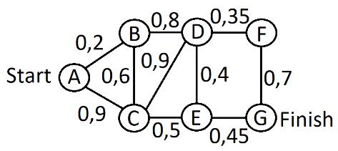
Graph 9, but the numbers indicate % chance of not getting stuck in a traffic jam.
Consider the route ABDFG.
Probability of not getting stuck in a traffic jam is:
P_{A,G} = P_{A,B} x P_{B,D} x P_{D,F} x P_{F,G}
P_{A,G} = 0,2 x 0,8 x 0,35 x 0,7 ≈ 0,04
Can we directly apply Dijkstra’s algorithm to find the most-reliable route?

Applying Dijkstra In A Non-Standard Setting
Recall that log(xy) = log (x) + log (y).
Therefore, log(P_{A,G} ) = log(P_{A,B}) + log(P_{B,D}) + log(P_{D,F}) + log(P_{F,G}).
Dijkstra’s algorithm minimises a sum, but we want to maximize a sum.
We can use a trick: The route that maximises log(P_{A,G} ) will minimize - log(P_{A,G} ).
We want to maximize a product, but Dijkstra doesn’t allow this.
We need to find a wat to rewrite our problem such that it becomes a problem of minimizing a sum.

Refinements
Up to now, we have considered two extremes:
1 The shortest route, not taking the reliability into account.
2 The most reliable route, not taking distance into account.

Normal Distribution
A random variable X is a variable whose possible values are outcomes of a random experiment.
We also use the term stochastic as a synonym for random.
A random variable X is called continuous when it can take continuously many values, for simplicity we can just say that its values are real numbers.
For a continuous random variable, we can specify the probability it falls in a range of values using the probability density function.
Mean (expectation): the (weighted) average value of all outcomes.
Standard deviation: on average, how far are we from the expectation.
X~N(µ,σ²).
The random variable X has normal distribution with mean µ and standard variation σ.
If X~N(µ,σ²), then the average of the values realised is µ.
If X~N(µ,σ), then the average of the values realised from µ is σ.
For a continuous random variable X, the probability that X lies on interval [a, b] can be calculated through its probability distribution function f_{x}(X), of which the answers are in the table below.
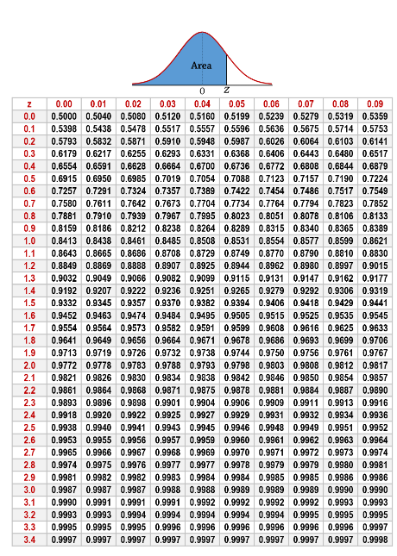

Example: for Z~N(0,1), it is that:
P(Z≤1,29) = 0,9015
P(Z≤1,29) = 0,5998
P(Z≤1,29) = 0,9868
P(Z≤0) = 0,5000

P(Z=t) = 0
P(Z≥t) = 1- P(Z≤t), therefore:
P(Z≥1,05) = 1- 0,8531 = 0,1469

P(Z≤-t) = P(Z≥t) = 1- P(Z≤t)
P(Z≤-0,25) = P(Z≥0,25) = 1- P(Z≤0,25) = 1-0,5987 = 0,4013

If X~N(µ,σ²), we will use the following: Z = (X- µ)/ σ~N(0,1)
Therefore, for X~N(3,4)
P(X≤5)
Z = (X-3)/2~N(0,1)
P(X≤5) = P((X-3)/2 ≤ (5-3)/2) = P(Z≤1) = 0,8413

Exercise 19
Verify the claim in (3.2.1), that is P(T_{1,2}≥20) > P(T_{1,3}≥20). Recall that T_{1,2}~N(12,16) and T_{1,3}~N(15,4).
Z = (T_{1,2} - 12)/4 ~ N(0,1)
P(T_{1,2}≥20) = P((T_{1,2} - 12) ≥ (20-12)/4) = P(Z≥2) = 1 – P(Z≤2) = 1 - 0,9772 = 0,0228
Z = (T_{1,3} - 12)/4 ~ N(0,1)
P(T_{1,3}≥20) = P((T_{1,3} - 15) ≥ (20-15)/4) = P(Z≥2,5) = 1 – P(Z≤2,5) = 1 - 0,9938 = 0,0062
0,0228>0,0062, and therefore P(T_{1,2}≥20) > P(T_{1,3}≥20).

Exercise 21
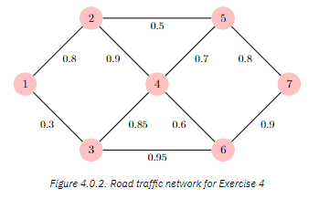
Figure 4.0.2 shows the possible routes to move from city 1 to city 7, and the associated probabilities of not running into a traffic jam. Use Bi-directional Dijkstra’s algorithm to find the most reliable route of this road traffic network. What is the probability of not getting stuck in a traffic jam on the most reliable route?
To use Dijkstra, we need to make this a shortest-route problem. Recalling “The route that maximises log(P_{A,G} ) will minimize - log(P_{A,G} )” from “Applying Dijkstra In A Non-Standard Setting” from page 18, we can use the negative logarithm of the value in 4.0.2 to make this a shortest-route problem. The negative logarithm values are in the graph below.
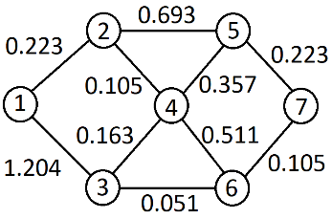
Graph 10, which has the negative logarithm values of figure 4.0.2
Forward:
2 | 3 | 4 | 5 | 6 | 7
0,223, 1 | 1,204, 1
* | 1,204, 1 | 0,328, 2 | 0,916, 2
* | 0,491, 4 | * | 0,685, 4 | 0,839, 4
* |  | *
* |  | *
* |  | *
* |  | *
Backward:
1 | 2 | 3 | 4 | 5 | 6
 |  |  |  | 0,223, 7 | 0,105, 7
 |  | 0,156, 6 | 0,616, 6 | 0,223, 7 | *
1,360, 3 |  | * | 0,319, 3 | 0,233, 7 | *
 |  | * |  |  | *
 |  | * |  |  | *
 |  | * |  |  | *

In line 3 of the Bi-directional Dijkstra, 3 becomes a permanent node for both algorithms, meaning that the shortest route is 124367.
The probability of not getting stuck in a traffic jam is:
-log(P_{1,7}) = -log(P_{1,2}) + -log(P_{2,4}) + -log(P_{4,3}) + -log(P_{3,6}) + -log(P_{6,7}) = 0,233 + 0,105 + 0,163 + 0,051 + 0,105 = 0,647
Which gives P_{1,7} = e^{-0,647} ≈ 0,524
Therefore, the probability of not getting stuck in a traffic jam on the most reliable route is 52,4%.

Travel Time As Random Variable
Instead of distance, we are now going to work with travel times.
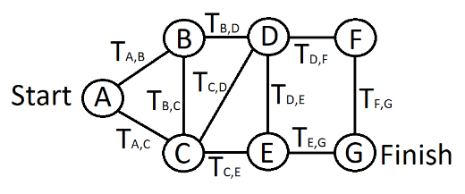
Graph 9 with Stochastic Travel Times
Travel times can be uncertain for many reasons.
We model travel times as random variables.
The travel times T_{i,j} have a mean (µ) and a variance (σ).
Suppose that T_{1,3} has a mean 15 and a variance 4
Suppose that T_{1,2} has a mean 12 and a variance 16
 | T_{A,B} | T_{A,C} | T_{B,C} | T_{B,D} | T_{C,D} | T_{C,E} | T_{D,E} | T_{D,F} | T_{E,G} | T_{F,G}
µ | 12 | 10 | 2 | 7 | 4 | 4 | 3 | 10 | 19 | 5
σ² | 1 | 9 | 1 | 9 | 4 | 1 | 1 | 16 | 1 | 4

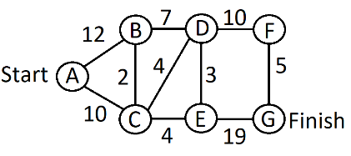
Graph 9 with travel times
B | C | D | E | F | G
12, A | 10, A
12, A | * | 14, C | 14, C
* | * | 14, C | 14, C
* | * | 14, C | * |  | 33, E
* | * | * | * | 24, D | 33, E
* | * | * | * | * | 29, F

Therefore, the quickest route is ACDFG.

Arriving In Time
What if you want to find the route that maximises the probability of arriving at your destination in time?
This could be a completely different route from everything and can’t be found using Dijkstra.
If interested in expected travel time: T_{1,2} with mean 12 preferred over T_{1,3} with mean 15.
If interested in probability of arriving within 20 minutes:
P(T_{1,2}<20) = 0,9772 and P(T_{1,3}<20) = 0,9938 (see exercise 19)
Then, T_{1,3} is preferred.
P(T₁ + T₂ < 20) ≠ P(T₁ < 20) + P(T₂ < 20)
P(T₁ + T₂ < 20) ≠ P(T₁ < 20) x P(T₂ < 20)

Exercise 22

Graph 9 with Stochastic Travel Times
- Assume that the travel time distribution of the road traffic network in graph 9 with stochastic travel times is:
 | T_{A,B} | T_{A,C} | T_{B,C} | T_{B,D} | T_{C,D} | T_{C,E} | T_{D,E} | T_{D,F} | T_{E,G} | T_{F,G}
µ | 12 | 10 | 2 | 7 | 4 | 4 | 3 | 10 | 19 | 5
σ² | 1 | 9 | 1 | 9 | 4 | 1 | 1 | 16 | 1 | 4
Find the route between city A and G that has the lowest expected travel time.
- Suppose you have a job interview in 40 minutes. Find the probability that you arrive on time if you take the route you find in part (1). What is the probability if you take the route ACEG? What do you observe?
HINT: Recall that the travel times are independent across the different roads. You can use that if X ~ N(µx, σ²x) and Y ~ N(µx, σ²y) are independent, it holds that X + Y ~ N(µx+µy, σ²x + σ²y).
- The expected travel time is µ, so all we need to do is use Dijkstra to find the route that minimizes the sum of µ.
B | C | D | E | F | G
12, A | 10, A
12, A | * | 14, C | 14, C
* | * | 14, C | 14, C
* | * | 14, C | * |  | 33, E
* | * |  | * | 24, D | 33, E
* | * |  | * | * | 29, F
This gives us the path ACDFG with an expected travel time of 29 minutes.
(2)
 | T_{A,C} | T_{C,D} | T_{D,F} | T_{F,G}
µ | 10 | 4 | 10 | 5
σ² | 9 | 4 | 16 | 4
The table above gives N(29, 33).
$$P\left(T_{A-C-D-F-G}≤40\right)=P\left(\frac{T_{A-C-D-F-G}-29}{\sqrt{33}}≤\frac{40-29}{\sqrt{33}}\right)=P\left(Z≤1,9148\right)=0,9722$$
 | T_{A,C} | T_{C,E} | T_{E,G}
µ | 10 | 4 | 19
σ² | 9 | 1 | 1
The table above gives N(33, 11).
$$P\left(T_{A-C-E-G}≤40\right)=P\left(\frac{T_{A-C-E-G}-33}{√11}≤\frac{40-33}{\sqrt{11}}\right)=P\left(Z≤2,11\right)=0,9826$$
The observation that I make from these equations is that while the path ACDFG has a lower average time, but when taking path ACEG, you are more likely to arrive on time.

Concluding Remarks
Dijkstra’s algorithm is a very useful tool for determining shortest path. If you get a little bit creative with the input, it can calculate a lot more than just the shortest path.

